TABLE OF CONTENT

TABLE OF CONTENT i

1. INTRODUCTION 1

2. PROBLEM STATEMENT 1

3. OBJECTIVES 2

4. METHODOLOGY 2

4.1 REQUIREMENT IDENTIFICATION 2

4.1.1 LITERATURE REVIEW 2

4.1.2 REQUIREMENT ANALYSIS 3

4.2 FEASIBILTY STUDY 4

4.2.1 TECHNICAL FEASIBILITY 4

4.2.2 OPERATIONAL FEASIBILITY 4

4.2.3 ECONOMIC FEASIBILITY 4

4.2.4 SCHEDULE FEASIBILITY 5

4.3 SYSTEM DESIGN 6

4.4 USE CASE DIAGRAM 7

4.5 DESCRIPTION OF ALGORITHM 7

5. EXPECTED OUTCOME 9

REFERENCES

1. INTRODUCTION

The ‘Online Voting System’ implementation of the voting requirements and protocols during an election. It is an online voting system aimed at easing the voting procedure and reducing the election’s time duration.

The system is a web application where a person can cast vote after the verification of their personal information and can view the results of the ongoing election. The web application provides simple and intuitive user interface without ambiguity for easy and errorless voting. It can make the election conclude quickly and the money spent to provide wages to vote counters can be saved and used for something more productive.

Online voting system promotes e-governance and brings transparency in the election. This completely mitigates counting errors and theft of ballot boxes during the physical election – which happens often in Nepal during Elections. Along with benefits, it also brings forth problems. For instance, implementation and maintenance cost can be huge, prone to security attacks like hacking, etc. The solutions to these problems are following proper security regulations while building the system and hiring a cyber-security specialist for checking and improving the vulnerabilities. The system can be made short term i.e. making the voting system online only during the election period which can cut the maintenance cost.

1. PROBLEM STATEMENT

Election is the fundamental part of democracy which promotes the democratic decision making. However, Elections are the major financial burden for a nation like Nepal – where local and parliamentary election are conducted every few years. For instance, the local election of 2022 in Nepal brought forth the whopping expenditure of NPR 8.11 billion (USD 63.7 million) for Election Commission which is the highest till date. In essence, every few year millions of dollars are spent during election and the amount rising. Another problem with elections in Nepal is robbery of the ballot boxes which has happened during every election.

OVS aims at resolving these problem to great extent. Implementation of OVS will substantially reduce the cost and time for conducting election. OVS is not the foolproof solution to reduce election expenditure as its implementation and maintenance requires funding and politicians are going to spend above set limits, however, not having to pay wages to the counters, for as long as the day they take to count the votes, can save the amount from the set budget. It is also quite useful in case of the re-elections.

1. OBJECTIVES

* To review the existing voting process and coming up with a system to implement it.
* To reduce the time it takes from casting the vote to electing a candidate.
* To reduce the cost of conducting election.
* To improve e-governance index.
* To stop the robbery of ballot boxes.

1. METHODOLOGY

## 4.1 REQUIREMENT IDENTIFICATION

### 4.1.1 LITERATURE REVIEW

**E-Governance Development Index (EGDI):**

The E-Government Development Index presents the state of E-Government Development of the United Nations Member States. Along with an assessment of the website development patterns in a country, the E-Government Development index incorporates the access characteristics, such as the infrastructure and educational levels, to reflect how a country is using information technologies to promote access and inclusion of its people *(United Nations, 2022)*.

**“Estimated Cost of Election 2022” Nepal Economic Forum:**

The 2022 local elections have been projected to be one of the most expensive to date with a budget set at NPR 8.11 billion (USD 63.7 million) for the Election Commission, of which NPR 5.43 billion (USD 42.22 million) has been spent. The Election Commission is budgeted to spend NPR 12.2 billion (USD 95.8 million) and the Nepal Police is budgeted to spend NPR 7.99 billion (USD 62.75 million) for the federal and provincial elections to be held on November 2022. *(Shrestha, 2022)*

**“Introduction to Online Voting System” Nitin Bhasin:**

“Online Voting System” is an online voting technique. In this system people who have citizenship of Kenya and whose age is above 18 years and any sex can give their vote online without going to any physical polling system. There is a database which is maintained in which all the names of voters with complete information is stored. (Bhasin, 2013)

### 4.1.2 REQUIREMENT ANALYSIS

Requirement analysis is further divided into two categories: Functional and Non-functional requirement.

1. Functional Requirement:
2. Citizen Information Form: The system will have a form where a citizen can fill up their information, such as voter id number, name, age, etc.
3. Candidate Information: Voters can view the information about the candidates running in the election along with their past work history.
4. Vote Count: Voters can also see the leading candidates based on the vote count.
5. Non-functional Requirement:
6. User Verification: System can verify the eligibility of a voter based on the information provided in the citizen information form.
7. Accident Control: System prompts a pop-up when submitting vote to mitigate accidental votes.
8. Validation: System can validate the inputs provided by the user.
9. Security: System is secured with safety protocols and encryption strategies to protect the user’s information and itself.

## 4.2 FEASIBILTY STUDY

The purpose of this feasibility study is to investigate the practicality of the project and identify potential problems that might arise during the development and/or deployment after taking in all the factors into account. This chapter contains Technical, Operational, Economical and Schedule Feasibility.

### 4.2.1 TECHNICAL FEASIBILITY

This web application is built using HTML, CSS, JS for frontend scripting and Tailwind CSS library for better design whereas Python & Django for backend scripting. The project also requires an IDE like Visual Studio Code to run all these programming languages and libraries. All these tools are free of cost and easy to use. Hence, this project is technically feasible.

### 4.2.2 OPERATIONAL FEASIBILITY

Web application is equipped with helpful resources and hints to avoid ambiguity and eliminate errors. Interface is very user friendly that anyone can use it with ease. Therefore, this project passes the operational feasibility.

### 4.2.3 ECONOMIC FEASIBILITY

The only requirement of the project are developers with PC capable of running the IDE such as Visual Studio Code which is completely free. Since all developers have the computers with good specs and tools and software used are completely free. Only expenses are towards designers and developers, which is not a problem since we are the ones who are fulfilling all the roles. So, the project is economically feasible.

### 4.2.4 SCHEDULE FEASIBILITY

The project is estimated to take from three to four months to complete. The developers and designers have scheduled their time so as to complete the project within the estimated time frame keeping into account the time that it might take for post-production like testing, error fixing, etc. Therefore, the project is feasible in terms of schedule.

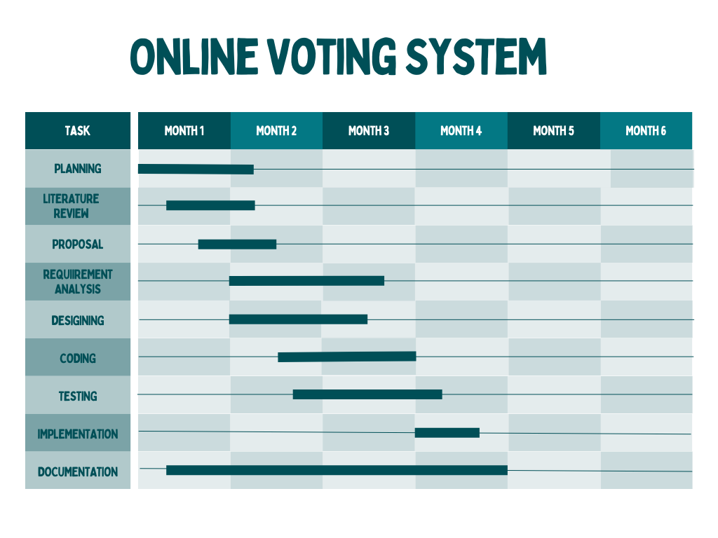

*Fig: GANTT Chart*

## 4.3 SYSTEM DESIGN

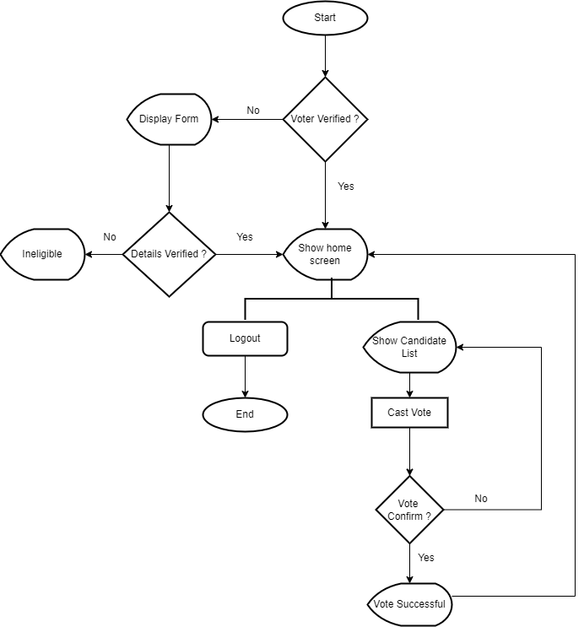

*Fig: Flow Chart*

## 4.4 USE CASE DIAGRAM

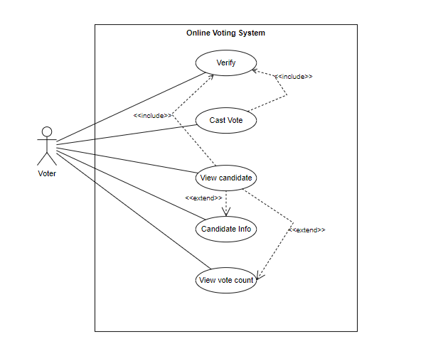

*Fig: Use case diagram*

## 4.5 DESCRIPTION OF ALGORITHM

**Iterative Model:**

In iterative Model, development begins with some of the software specifications and develop the first version of the software. After the first version if there is a need to change the software, then a new version of the software is created with a new iteration. Every release of the Iterative Model finishes in an exact and fixed period that is called iteration. In every iteration, improvements are made to the previous version and better version is created. Therefore, it is also called incremental model.

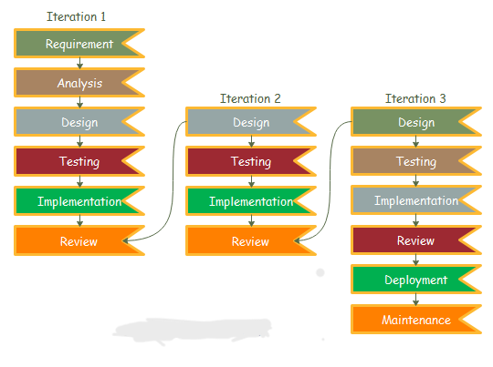

*Fig: Iterative Model*

**Sorting Algorithm:**

A sorting algorithm is a method used to rearrange elements in a list or array into a specific order, usually ascending or descending according to a defined comparison function. Sorting is a fundamental operation in computer science and is used extensively in various applications and algorithms.

Sorting algorithm can be quite useful in this project. The vote count of the various candidates can be exhibited in the decreasing fashion i.e. candidate with highest vote count at first and so on.

There are various kinds of sorting algorithms, with different time complexities, that can be used here such as bubble sort, heap sort, selection sort, quick sort, etc. Heap sort or quick sort are prefered as they have smaller time complexity compared to other. This can be quite useful when the dataset increases.

Pseudo code for Quick Sort:

QUICKSORT(A, p, r)

**if** p < r

q = PARTITION(A, p, r);

QUICKSORT(A, p, q-1);

QUICKSORT(A, q+1, r);

PARTITION(A, p, r)

x = A[r];

i = p – 1;

**for** j = p **to** r – 1

**if** A[j] <= x

i++;

exchange A[i] and A[j];

exchange A[i+1] and A[r];

return i + 1;

1. EXPECTED OUTCOME

Implementing the Online Voting System is cheaper and faster than the current methods which is the queuing system. This will reduce the cost and time it takes for election to complete. Voters can easily cast their precious vote from the comfort of their home rather than spending their time standing in the queues. Proper implementation and maintenance of the system during the election can help Nepal raise its E-Governance Development Index (EGDI) and improve its ranking.

REFERENCES

Bhasin, N. (2013, August 13). Project on Online Voting System.

Shrestha, S. (2022, September 06). *The cost of elections and its economic impacts: Nepal Economic Forum*. Retrieved from nepaleconomicforum.org: https://nepaleconomicforum.org/the-cost-of-elections-and-its-economic-impacts/

United Nations. (2022). *E-Government-Development-Index: United Nations Public Administration*. Retrieved from publicadministration.un.org: https://publicadministration.un.org/egovkb/en-us/About/Overview/-E-Government-Development-Index